 

INSTITUTE FOR ADVANCED COMPUTING AND SOFTWARE DEVELOPMENT AKURDI, (IACSD) PUNE.

Documentation On

“**ANNAPURNA ONLINE FOOD PORTAL**”

*PG-DAC SEPTEMBER 2022*

*Submitted By:*

**Group No: 4**

# Aditya Pawaskar (229004) , Rohan Sakale (229080)

**Mr. Rohit Puranik Mrs. Sonali Mogul**

**Centre Coordinator Project Guide**

# Table of Contents

1. Introduction 3

Problem Statement 3

Aim & Objectives 3

1. Overall Description 4

Proposed Methodology 4

Operating Environment 4

Design and Implementation Constraints 5

1. Requirements Specification 6

External Interface Requirements 6

1. System Diagram 7

Activity Diagram 7

Data Flow Diagram 10

Class Diagram 12

Use Case Diagram 13

ER Diagram 15

1. Table Structure 17

Course 17

Subject 17

Admin Student 17

Student 17

Admin Faculty 18

Faculty 18

Assignments 18

Notes 19

Classroom 19

Daily Schedule 19

Placements 19

Announcement 20

Contact Number 20

User 20

1. Conclusion 21

Future Scope 21

1. References 22

**List of Figures**

Figure 1 Admin Activity Diagram 7

Figure 2 Student Activity Diagram 8

Figure 3 Faculty Activity Diagram 9

Figure 4 Level 0 Data Flow Diagram 10

Figure 5 Level 1 Data Flow Diagram 10

Figure 6 Level 2 Data Flow Diagram for Admin 10

Figure 7 Level 2 Data Flow Diagram Course 11

Figure 8 Class Diagram 12

Figure 9 Use Case Diagram for Student 13

Figure 10 Use Case Diagram for Faculty 13

Figure 11 Use Case Diagram for Admin 14

Figure 12 ER (MySQL Auto Generated) 15

Figure 13 ER Diagram 16

**Introduction:**

# INTRODUCTION.

Annapurna food Portal is a web system that provides the function and features to authenticate and identify the customers (users), restaurant managers and delivery persons. Portal provide user with easy, personalized web-interface for facilitating access to restaurant information and food services that are of primary relevance and interests to the users. Annapurna food Portal is nothing but a portal which thinks customers as the main target users and provides so many useful services to customers at a single place. It helps to deliver various cuisine from various restaurant to customers with the help of delivery person.

## Problem Statement:

There are many problems found in the today’s food portal system. The problems created in the existing system enforced us to develop the new system which minimize the problem of the existing system. The problems are Low quality of food, Unhygienic kitchen and lack of inclusion of all type of food. Its application depends on location of the customer and location of restaurant.

## Aims and Objective:

The main purpose of this system, is to increase the awareness about various food available in an area. To make cross cultural awareness among the people and to generate the feeling of oneness. Provide on time delivery of foods. In other words, our Annapurna food portal has, following objectives:

* Simple database is maintained.

* Easy operations for the operator of the system.

User interfaces are user accommodating and attractive; it takes very less time for the to use the system.



*Easy operations for the operator of the system.

**Proposed Methodology:**

# OVERALL DESCRIPTION.

This system provides an easy way for customers to view and order the various cuisines. Restaurant staff to manage their food orders and deliver the food with help of delivery persons. The online food portal enables restaurants (system user) to showcase their cuisines online, customers to browse through portal can buy the food. This product aimed towards a person who don’t want to visit the restaurants but want to taste the food in his home or office etc. She/he can use the web application for ease.

## Operating Environment:

Server Side:

**Processor:** Intel® Core i5 8th Gen

**HDD:** Minimum 1TB Disk Space

**RAM:** Minimum 8GB **OS:** Windows 10, Linux 6 **Database:** MySQL

Client Side (minimum requirement):

**Processor:** Intel Dual Core

**HDD:** Minimum 500GB Disk Space

**RAM:** Minimum 4GB

**OS:** Windows 10, Linux

## Design and Implementation Constraints:

* The application will use ReactJs as frontend and Java spring Boot Api as a backend.
* The application will use JavaScript, JQuery and CSS as web technologies.
* HTTP and FTP protocols are used as communication protocols. FTP is used to upload the web application in live domain and the client can access it via HTTP protocol.
* SMTP protocol is used for Email communication.
* Several types of validations make this web application a secured one and SQL Injections can also be prevented.
* Since Annapurna Online Food Portal is a web-based application, internet connection must be established.
* The Annapurna Online Food Portal will be used on PCs and will function via internet or intranet in any web browser.

**External Interface Requirements:**

# Requirements Specification.

User Interfaces:

* + All the users will see the same page when they enter in this website. This page asks the users a username and a password.
  + After being authenticated by correct username and password, user will be redirect to their corresponding profile where they can do various activities.
  + The user interface will be simple and consistence, using terminology commonly understood by intended users of the system. The system will have simple interface, consistence with standard interface, to eliminate need for user training of infrequent users.

Hardware Interfaces:

* + No extra hardware interfaces are needed.
  + The system will use the standard hardware and data communication resources.

This includes, but not limited to, general network connection at the server/hosting site, network server and network management tools.

Application Interfaces:

**Web Browser:**

The system is a web-based application; clients need a modern web browser such as Mozilla Firebox, Internet Explorer, Opera, and Chrome. The computer must have an Internet connection in order to be able to access the system.

Communications Interfaces:

* + This system uses communication resources which includes but not limited to, HTTP protocol for communication with the web browser and web server and TCP/IP network protocol with HTTP protocol.
  + This application will communicate with the database that holds all the Orders information. Users can contact with server side through HTTP protocol by means of a function that is called HTTP Service. This function allows the application to use the data retrieved by server to fulfil the request fired by the customer.

# System Diagrams.

## Activity Diagram:

*Customer Activity:

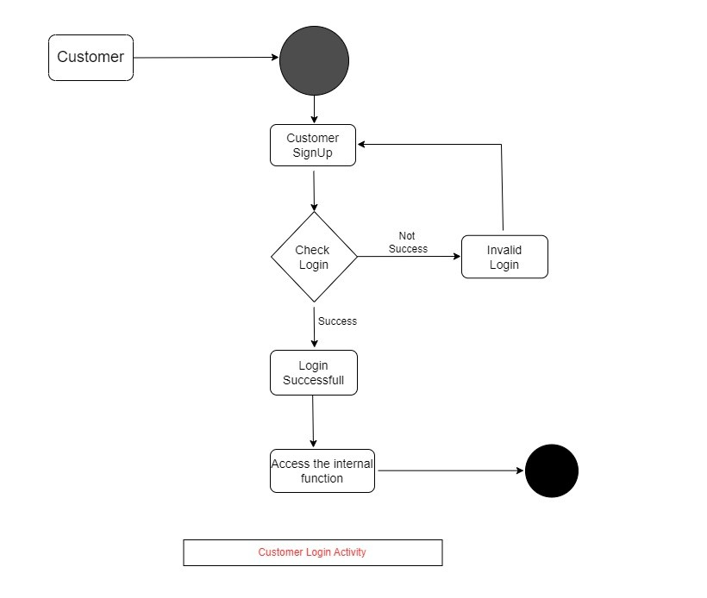

*Restaurant Manager Activity:

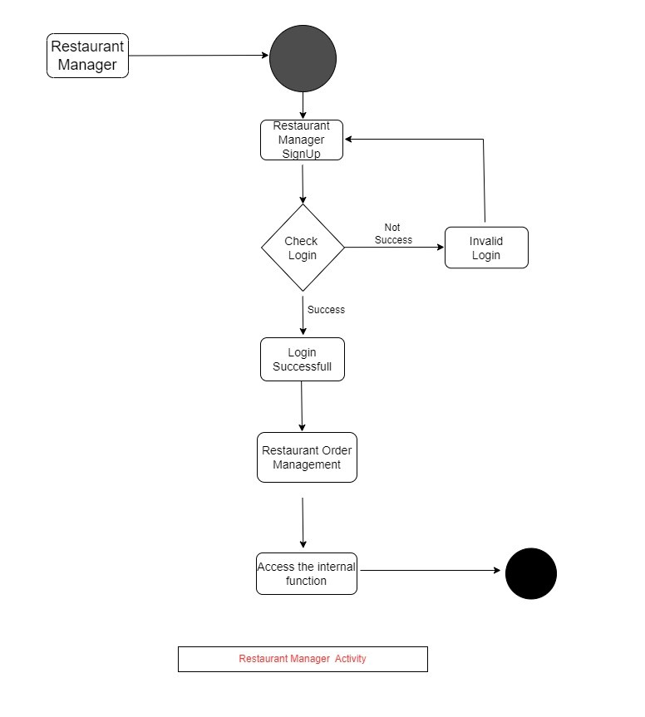

*Delivery Person Activity:

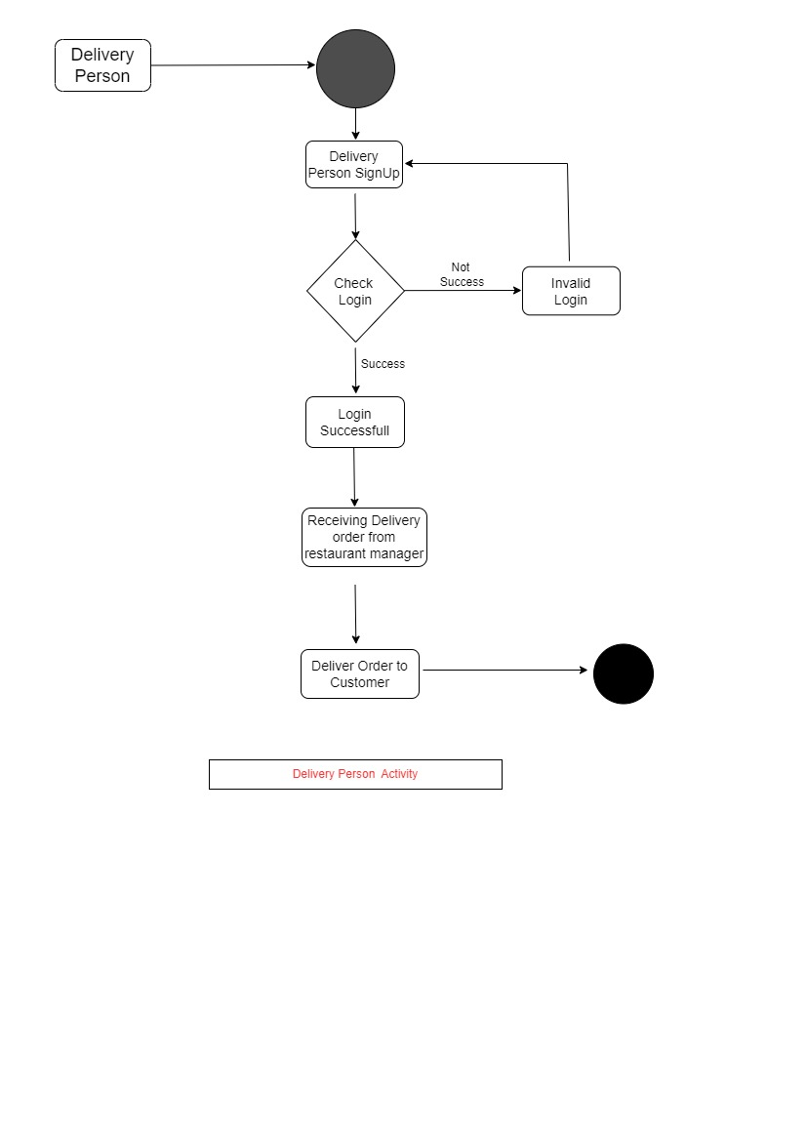

## Data Flow diagram:

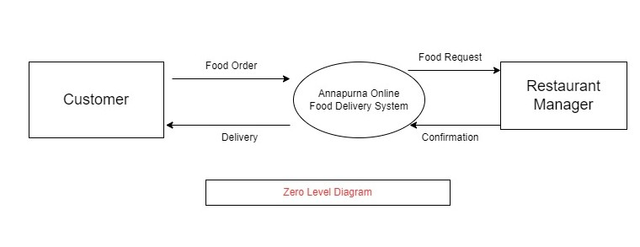

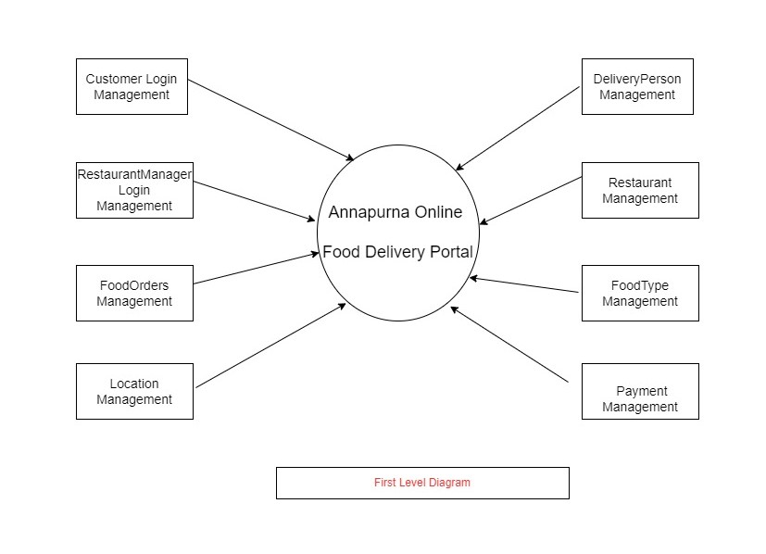

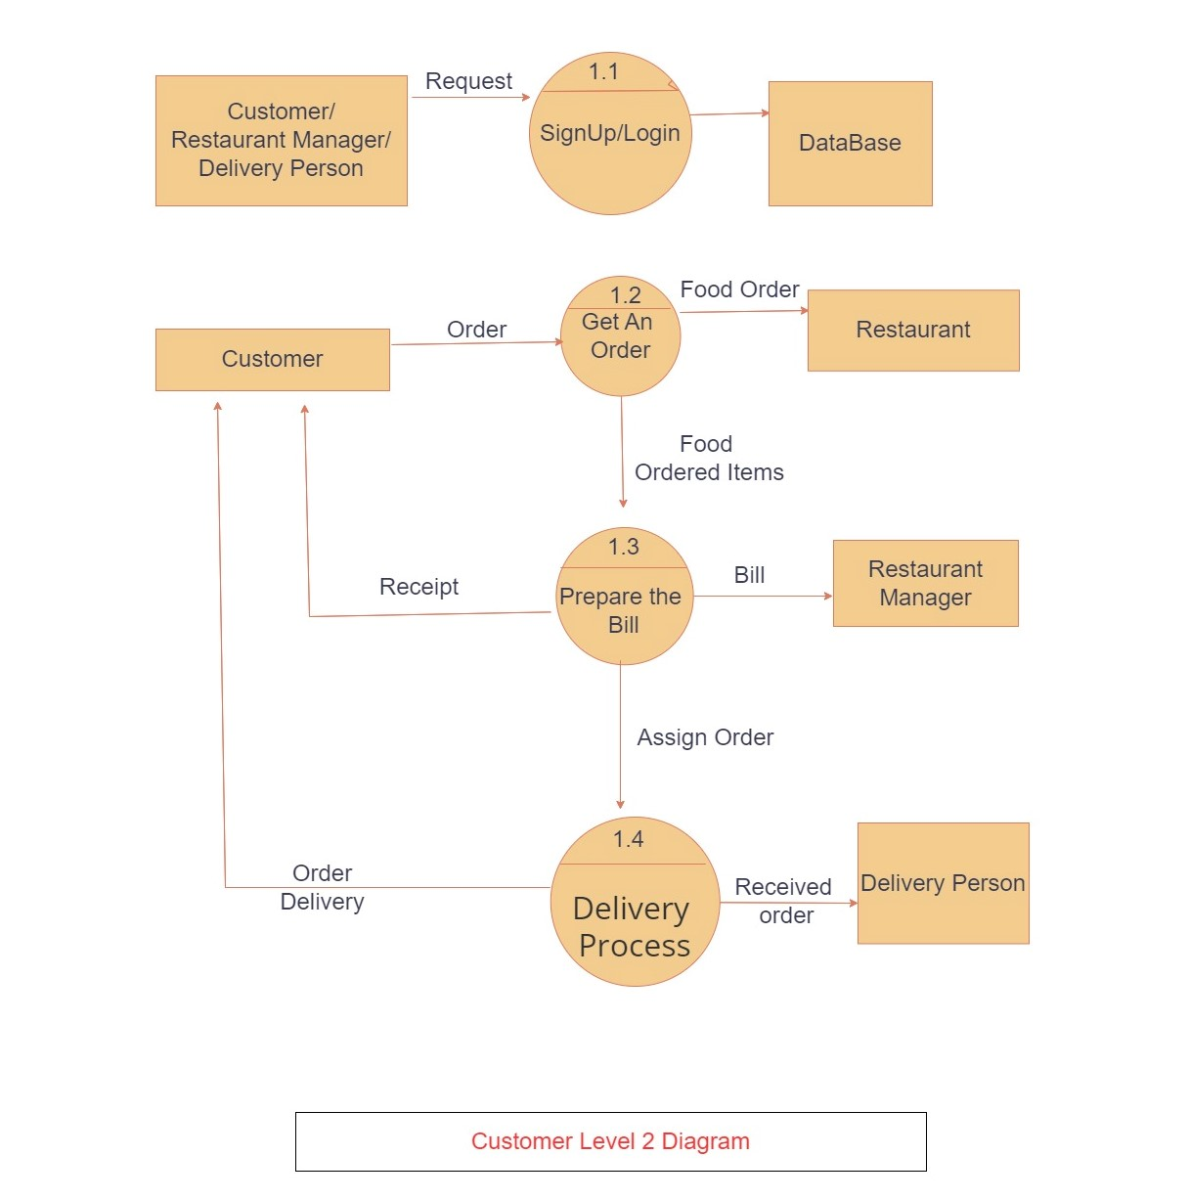

## Class Diagram:

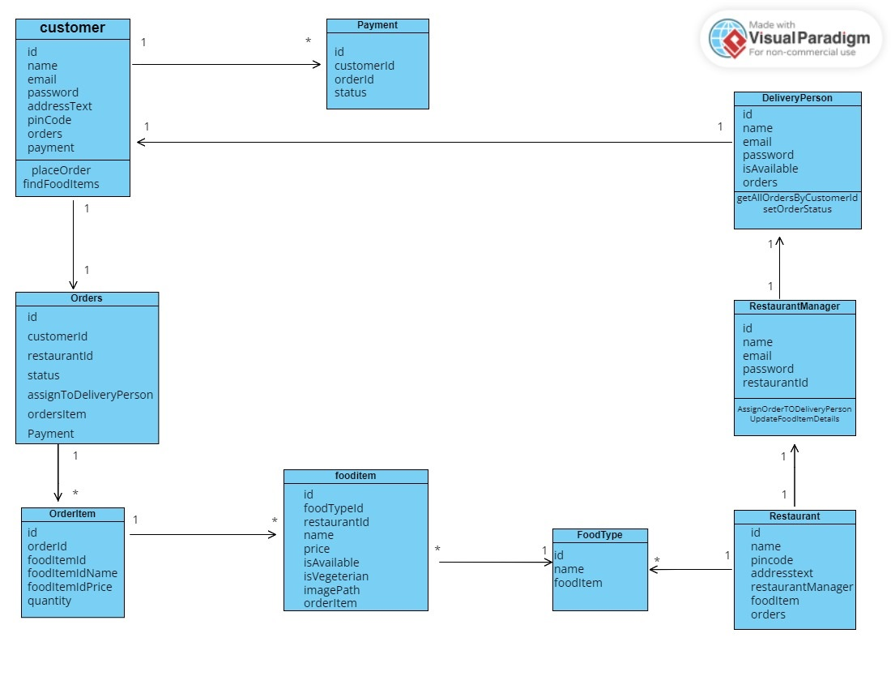

## Use Case Diagram:

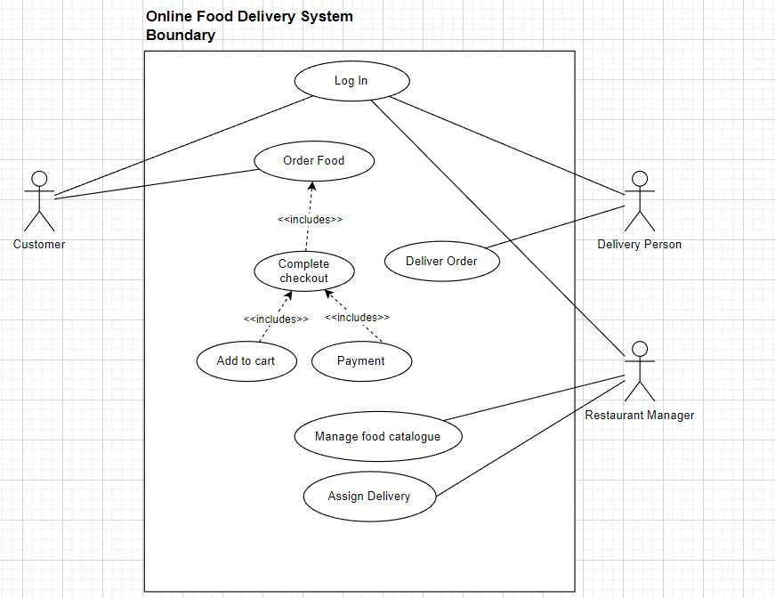

## ER Diagram:

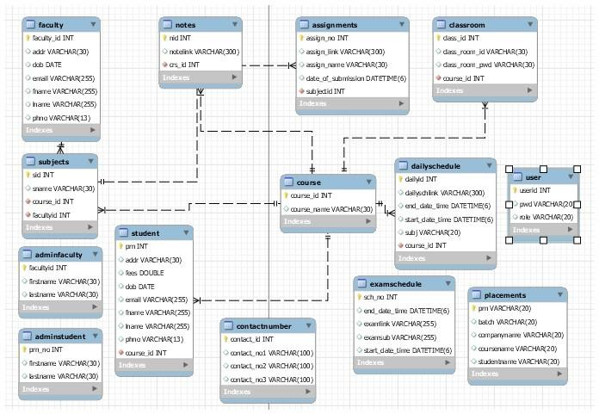

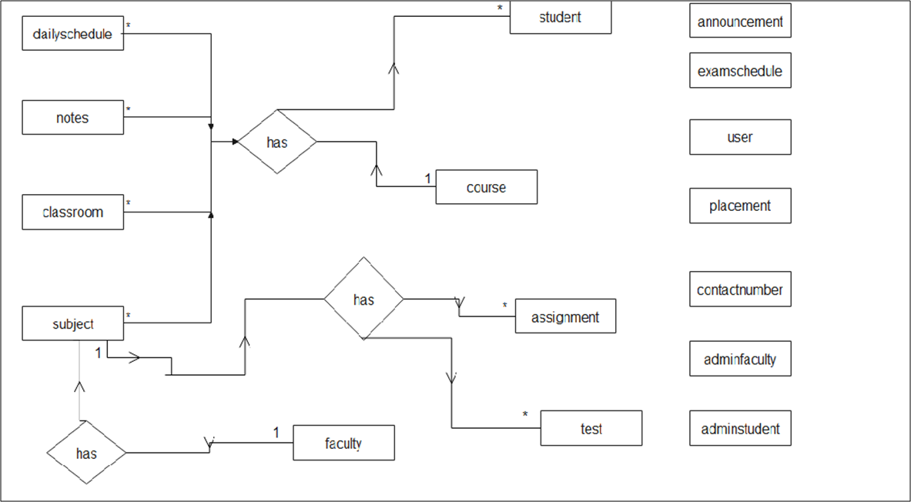

# Table Structure.

* + customer:

|  |  |  |  |  |  |
| --- | --- | --- | --- | --- | --- |
| Field | Type | Null | Key | Default | Extra |
| id | int | NO | PRI | NULL |  |
| Address_text | varchar(255) | YES |  | NULL |  |
| email | varchar(255) | YES |  | NULL |  |
| name | varchar(255) | YES |  | NULL |  |
| password | varchar(255) | YES |  | NULL |  |
| Pin_code | varchar(255) | YES |  | NULL |  |

* + delivery-person:

|  |  |  |  |  |  |
| --- | --- | --- | --- | --- | --- |
| Field | Type | Null | Key | Default | Extra |
| id | int | NO | PRI | NULL | auto_increment |
| email | varchar(255) | YES |  | NULL |  |
| Is_available | bit(1) | YES |  | NULL |  |
| name | varchar(255) | YES |  | NULL |  |
| Password | varchar(255) | YES |  | NULL |  |

* + food item:

|  |  |  |  |  |  |
| --- | --- | --- | --- | --- | --- |
| Field | Type | Null | Key | Default | Extra |
| id | int | NO | PRI | NULL | auto_increment |
| Image_path | varchar(255) | YES |  | NULL |  |
| Is_available | bit(1) | YES |  | NULL |  |
| Is_vegeterian | bit(1) | YES |  | NULL |  |
| name | varchar(255) | YES |  | NULL |  |
| price | double | YES |  | NULL |  |
| food_type_id | int | YES | MUL | NULL |  |
| restaurant_id | int | YES | MUL | NULL |  |

* + food type:

|  |  |  |  |  |  |
| --- | --- | --- | --- | --- | --- |
| Field | Type | Null | Key | Default | Extra |
| id | int | NO | PRI | NULL | auto_increment |
| name | varchar(255) | YES |  | NULL |  |

* + Admin Faculty:

|  |  |  |  |  |  |  |
| --- | --- | --- | --- | --- | --- | --- |
| Field | Type | Null | Key | Default |  | Extra |
| facultyid | int | NO | PRI | NULL |  | auto_increment |
| firstname | varchar(30) | YES |  | NULL |  |  |
| lastname | varchar(30) | YES |  | NULL |  |  |

* + Faculty:

|  |  |  |  |  |  |
| --- | --- | --- | --- | --- | --- |
| Field | Type | Null | Key | Default | Extra |
| facultyid | int(11) | NO | PRI | NULL | auto_increment |
| fname | varchar(30) | YES |  | NULL |  |
| lname | varchar(30) | YES |  | NULL |  |
| phno | varchar(30) | YES |  | NULL |  |
| dob | datetime(6) | YES |  | NULL |  |
| email | varchar(30) | YES |  | NULL |  |
| address | varchar(50) | YES |  | NULL |  |
| faculty | int | YES | MUL | NULL |  |

* + Assignment:

|  |  |  |  |  |  |
| --- | --- | --- | --- | --- | --- |
| Field | Type | Null | Key | Default | Extra |
| assign_no | int | NO | PRI | NULL | auto_increment |
| assign_link | varchar(300) | YES |  | NULL |  |
| assign_name | varchar(30) | YES |  | NULL |  |
| date_of_submission | datetime(6) | YES |  | NULL |  |
| subjectid | int | NO | MUL | NULL |  |

* + Notes:

|  |  |  |  |  |  |
| --- | --- | --- | --- | --- | --- |
| Field | Type | Null | Key | Default | Extra |
| nid | int | NO | PRI | NULL | auto_increment |
| notelink | varchar(300) | YES |  | NULL |  |
| crs_id | int | YES | MUL | NULL |  |

* + Classroom:

|  |  |  |  |  |  |
| --- | --- | --- | --- | --- | --- |
| Field | Type | Null | Key | Default | Extra |
| class_id | int | NO | PRI | NULL | auto_increment |
| class_room_id | varchar(30) | YES |  | NULL |  |
| class_room_pwd | varchar(30) | YES |  | NULL |  |
| course_id | int | NO | MUL | NULL |  |

* + Daily Schedule:

|  |  |  |  |  |  |
| --- | --- | --- | --- | --- | --- |
| Field | Type | Null | Key | Default | Extra |
| dailyId | int(10) | NO | PRI | NULL | auto_increment |
| startDateTime | datetime | YES |  | NULL |  |
| endDateTime | datetime | YES |  | NULL |  |
| dailySchLink | varchar(300) | YES |  | NULL |  |
| courseId | int(10) | NO | MUL | NULL |  |
| subjectName | varchar(30) | YES |  | NULL |  |

* + Placements:

|  |  |  |  |  |  |
| --- | --- | --- | --- | --- | --- |
| Field | Type | Null | Key | Default | Extra |
| prn | varchar(20) | NO | PRI | NULL |  |
| batch | varchar(20) | YES |  | NULL |  |
| companyname | varchar(20) | YES |  | NULL |  |

|  |  |  |  |  |  |
| --- | --- | --- | --- | --- | --- |
| coursename | varchar(20) | YES |  | NULL |  |
| studentname | varchar(20) | YES |  | NULL |  |

* + Announcement:

|  |  |  |  |  |  |
| --- | --- | --- | --- | --- | --- |
| Field | Type | Null | Key | Default | Extra |
| ansm_id | int | NO | PRI | NULL | auto_increment |
| ansm_name | varchar(500) | YES |  | NULL |  |

* + Contact Number:

|  |  |  |  |  |  |
| --- | --- | --- | --- | --- | --- |
| Field | Type | Null | Key | Default | Extra |
| contact_no1 | int | NO | PRI | NULL | auto_increment |
| contact_no2 | varchar(100) | YES |  | NULL |  |
| contact_no3 | varchar(100) | YES |  | NULL |  |
| contact_no4 | varchar(100) | YES |  | NULL |  |

* + User:

|  |  |  |  |  |  |
| --- | --- | --- | --- | --- | --- |
| Field | Type | Null | Key | Default | Extra |
| userid | int | NO | PRI | NULL |  |
| password | varchar(30) | YES |  | NULL |  |

* + **Conclusion:**

# CONCLUSION

This project aid in automating the existing manual system. This is a paperless work. It can be monitored and guarded remotely. It cut down the man power required and provides accurate information. All years together huddled information can be saved and can be accessed at any time. For this reason, the data stored in the repository helps in taking decision by management. So, it is improved to have a Web Based system. All the stakeholders, faculty and authority can get the required information without delay. This system is crucial in the colleges and universities.

## Future Scope:

This project can be enhanced further by adding payable additional courses, online feedback system, online payment facility for the members to reduce the extra work of the admin. The software is flexible enough to be modified and implemented as per future requirements. We have tried our best to present this free and user–friendly website to Institutes.

# REFERENCES.

## References:

****<http://www.ijcstjournal.org/volume-7/issue-1/IJCST-V7I1P4.pdf> <https://bootstrapmade.com/mentor-free-education-bootstrap-theme/> <https://www.javatpoint.com/java-mail-api-tutorial> https://[angular.io/docs](https://angular.io/docs)

**<https://javaee.github.io/javaee-spec/javadocs>[/](https://javaee.github.io/javaee-spec/javadocs/) <https://www.w3schools.com/>